Assignment: 4

To make firefox of our own we need some pre requisites:

* 64-bit version of Windows 7 or later
* About 40GB of free space on hard drive

The first step is the system requirements check.

Next step is to install Visual Studio Pro

We had to make sure that the following kits were included in our Visual Studio 2019:

* “Desktop development with C++” with the components “Windows 10 SDK” and “C++ ATL for v142 build tools (x86 and x64)”
* “Game development with C++”

The next step was to Build Mozilla from Visual Studio’s default main menu. Once I did, the following notifications showed up:

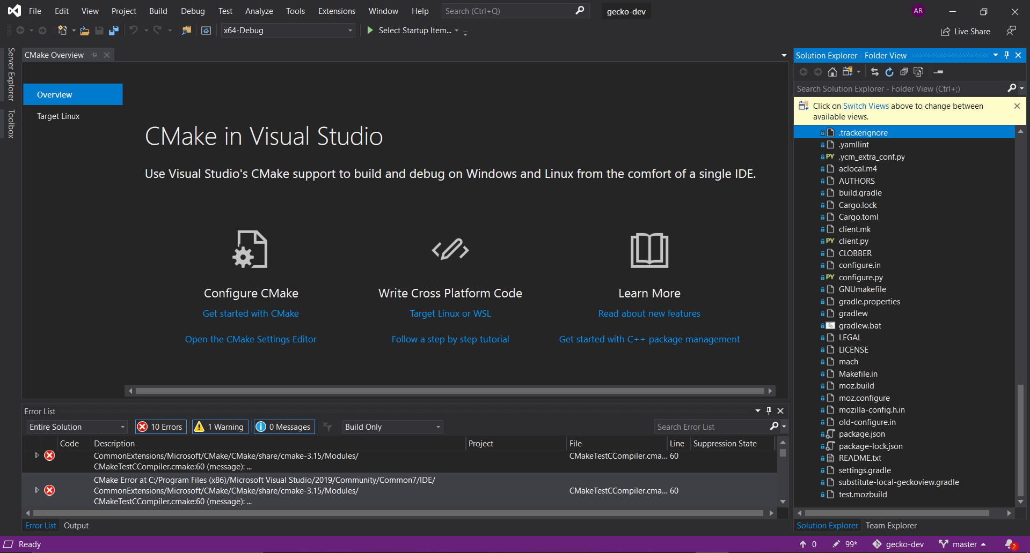

There were a total of 10 errors and 1 warning all on CMake.